QHSE
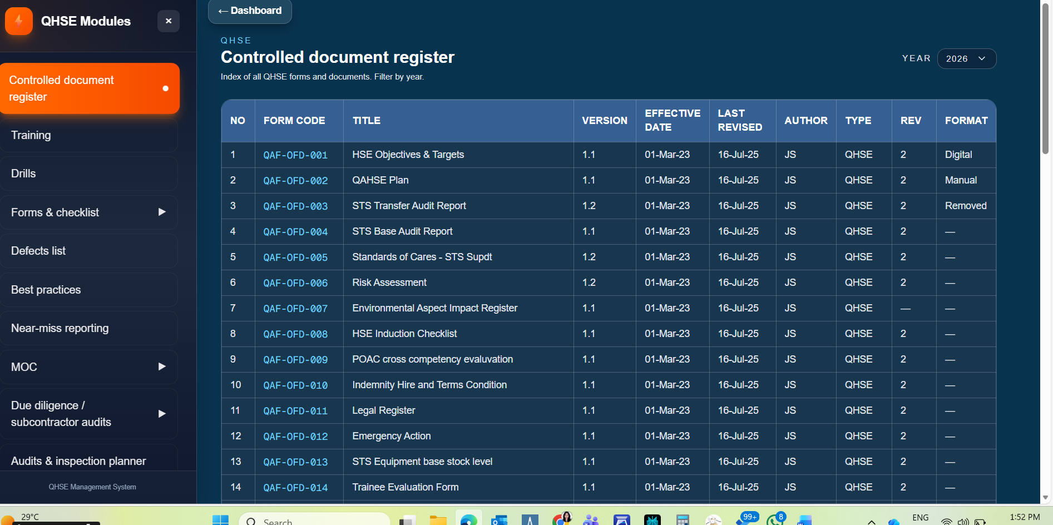
This control register view is good , but it should include all the datas form the excel documents given including , QHSE , Operations, HR, Admin , etc.,/ also there is no edit option ?
If this section has year wise filter , then there should be an option to copy paste o route the data which is already resent for each year .
There Is no download option ?
Full demo needed for training and drill module.

Please advise in our present system , we store blank form of all forms In a folder and where just like that we download the form fill it and upload , but none of this module has the has the option to download the blank for any particular section .
Require some light on this .

